Chapter 17, Solution 81.

(a)
0
T
2T
3T
A

f(t) = 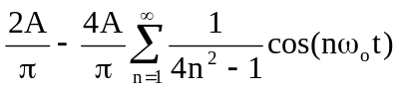

The total average power is p_{avg} = F_{rms}²R = F_{rms}² since R = 1 ohm.

P_{avg} = F_{rms}² = 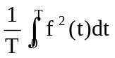 = 0.5A²

(b) From the Fourier series above

|c_{o}| = 2A/π, |c_{n}| = |a_{n}|/2 = 2A/[π(4n² – 1)]

n | ω_{o} | |c_{n}| | |c_{o}|² or 2|c_{n}|² | % power
0 | 0 | 2A/π | 4A²/(π²) | 81.1%
1 | 2ω_{o} | 2A/(3π) | 8A²/(9π²) | 18.01%
2 | 4ω_{o} | 2A/(15π) | 8A²/(225π²) | 0.72%
3 | 6ω_{o} | 2A/(35π) | 8A²/(1225π²) | 0.13%
4 | 8ω_{o} | 2A/(63π) | 8A²/(3969π²) | 0.04%

(c) 81.1%

(d) 0.72%

